German playgroundgames

Schnitzeljagd

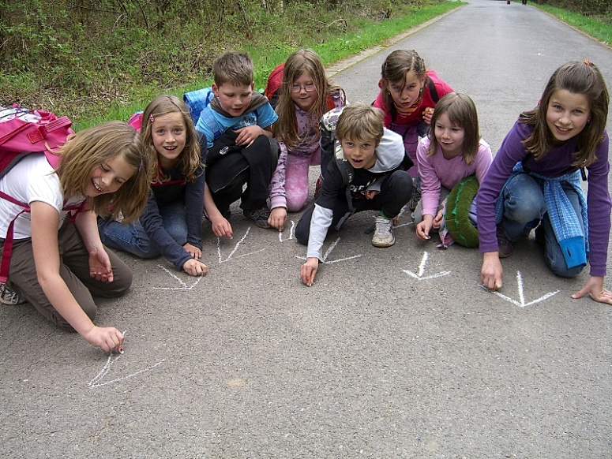
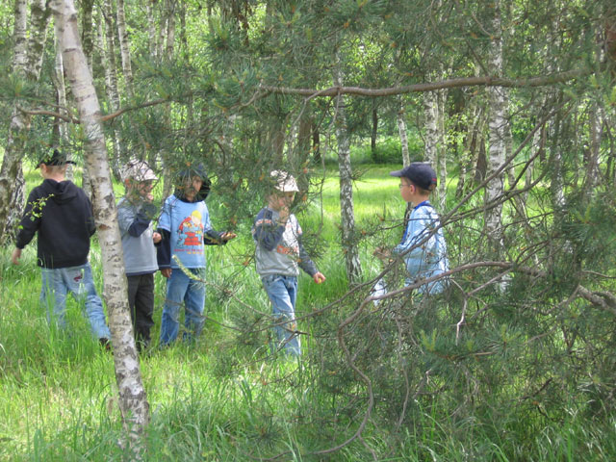
- Schnitzelijagd can be translated as "paper chase." In this game, children are divided into two groups with one group the hunters and the other group the hunted. The hunted children, who must reach a designated location before being caught, are given a minute or two head start. They are supposed to leave a trail of bits of paper, branches or rocks. One trail must indicate the children's actual path, but extra markers can be left to confuse the hunters. An "X" should be placed at the end of any false trails.

Topfschlagen
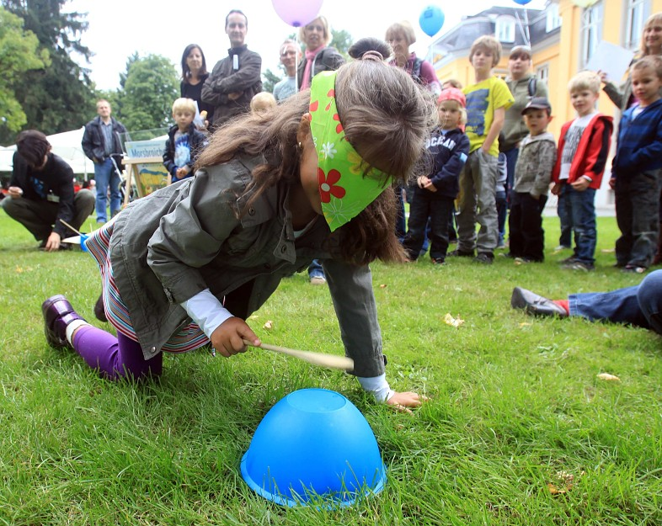
- Topfschlagen, or Hit the Pot, is a German game for small children. One child is chosen and is supposed to keep his eyes closed while another child hides a pot with a prize underneath it somewhere in the room. The child with the closed eyes is then given a cooking spoon to beat on the floor until he finds the pot and gets the prize. Then another child takes a turn finding the pot with a new prize underneath.

Der Plumsack Geht Um
- Der PlumsackGeht Um ("The Plumsack Goes Around") is played like "Duck, Duck, Goose." The group stands in a large circle facing in, and one person is “It.” The person playing “It” holds a small stone or a ball (traditionally, a little bag of rice), and walks round the circle while the group sings “Der Plumsackgeht um, der Plumsackgeht um.” The child then drops the plumsack behind one member of the circle, who must now chase the child playing “It” and try to tag him out. The child playing “It” tries to make it back around the circle to the chosen member’s original space. If “It” is successful, the chaser is now “It” and the game repeats. If “It” is tagged, she must go to the center of the circle and remain out until another “It” is tagged in a later game.
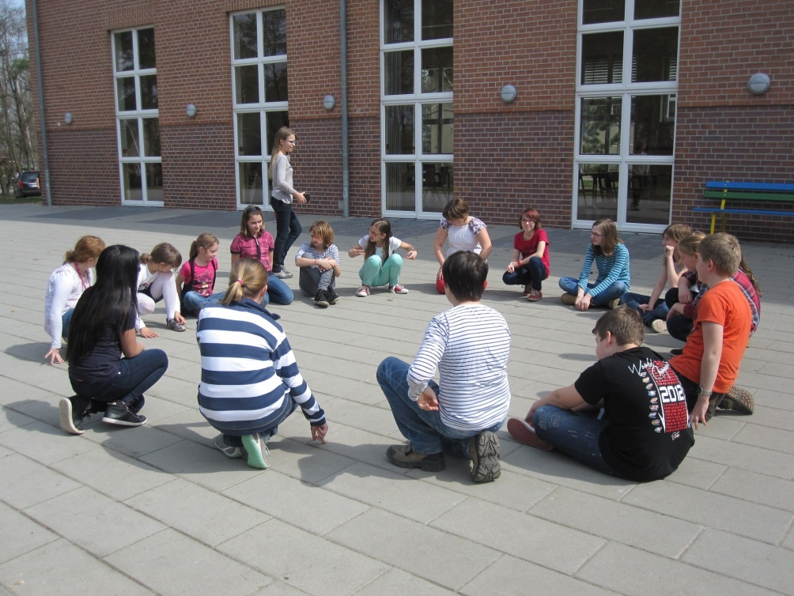

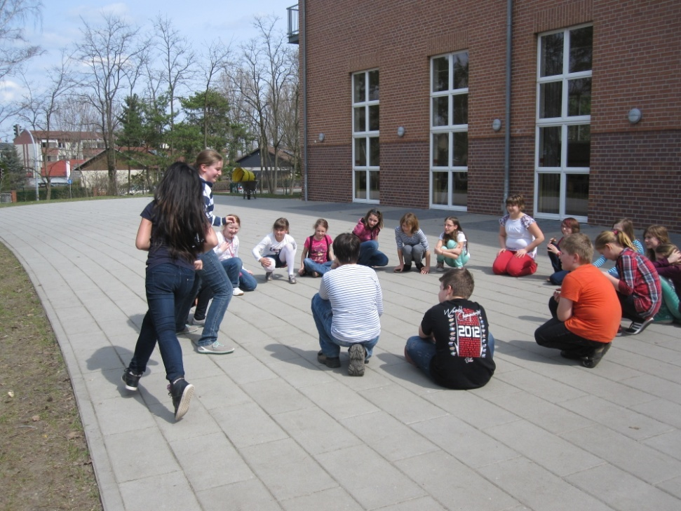

Katz und Maus
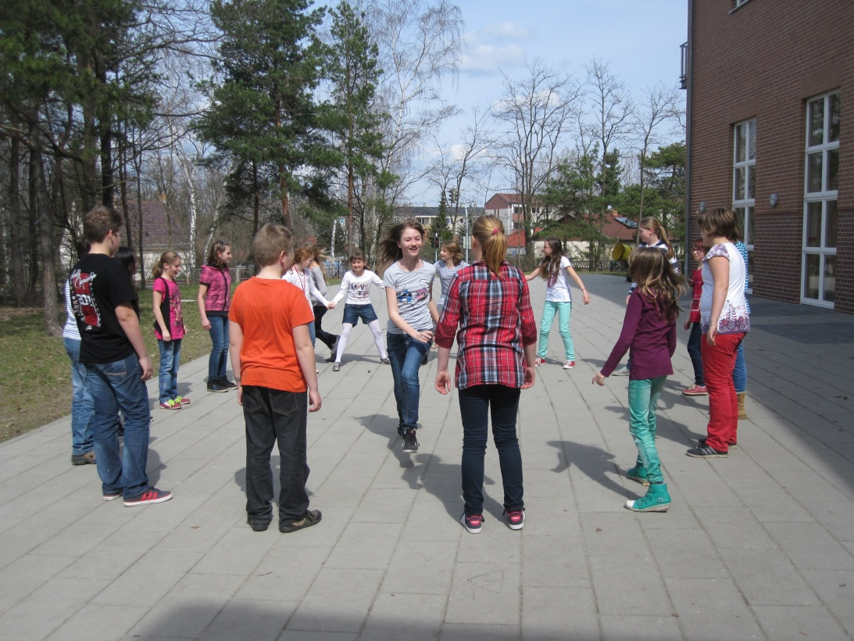
- Katz und Maus is literally a game of “cat and mouse.” The group forms a circle and joins hands. One child is the “Katz” and another “Maus.” The cat must tag the mouse by chasing him in and out of the circle of children. The children help by raising and lowering their arms for the cat as the child passes through the circle. When the mouse is caught, that child becomes the cat and may choose a mouse from the children in the circle.
